

ETL Documentation with screenshots

Fudgemart Inc – Order Fulfillment



**Group 5F**

**Anushi Doshi** (Data Engineer and ETL Architect)

**Avin Deshmukh** (BI Architect)

**Parth Lodaria** (Data Architect and ETL Architect)

**Pranjal Sondkar**(BI Analyst)

**Rajvee Shah** (BI Analyst and ETL Architect)

**Tanvi Borkar** (Project Manager and ETL Architect)

# Importing the Date Dimension:

First data is copied from the v_date_dimension in the ExternalSources database to a table called stgDate in your stage database. Next, after we complete the stage, we will map columns from the stgDate source into the column names used by DimDate in the dw database. We’ll apply Type 1 SCD rules to ensure we do not import the same data more than once.

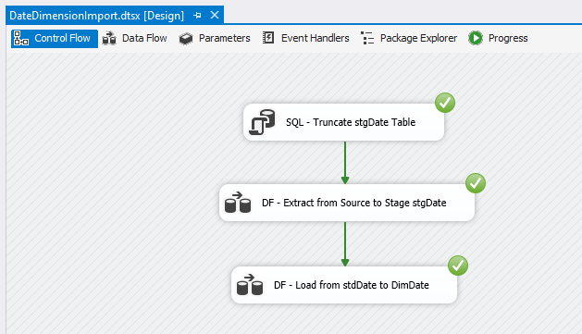

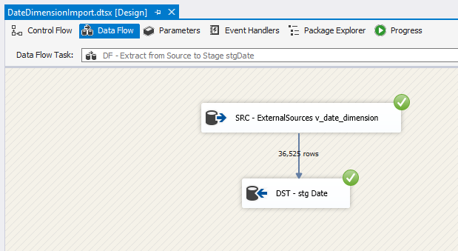

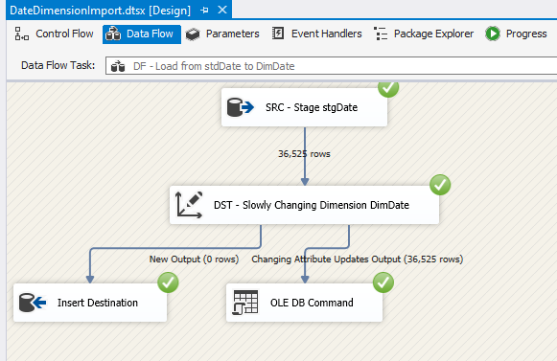

# Staging of Dim tables and Fact Table:

We created a package which performs half of the ETL process, collecting data from our sources and staging the data with no transformations to the data called

1. Stage_Fudgemart_OrderFulfillment.dtsx
2. Stage_Fudgeflix_OrderFulfillment.dtsx

We will simply copy data from source into our staging database. Again, we will use the truncate and load pattern so that each time the package executes, the stage tables are emptied.

## Fudgemart Staging:

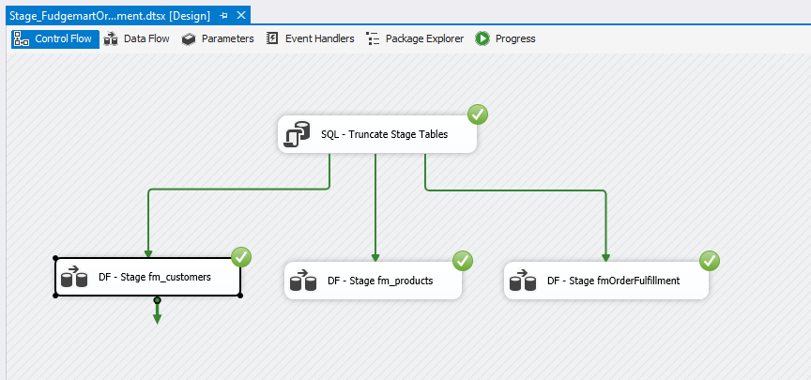

### DF – Stage FM_customers

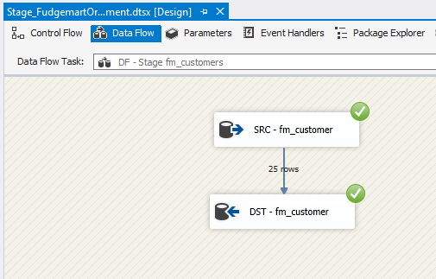

### DF – Stage FM_Products

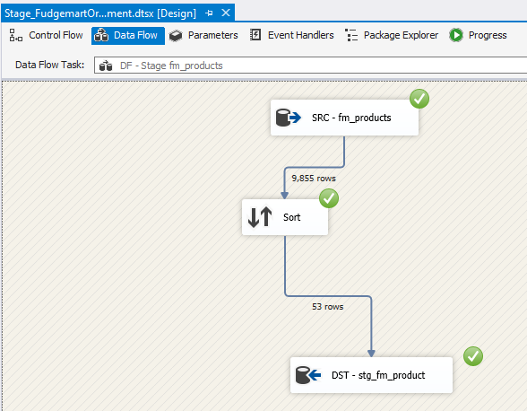

### DF – Stage Order Fulfillment

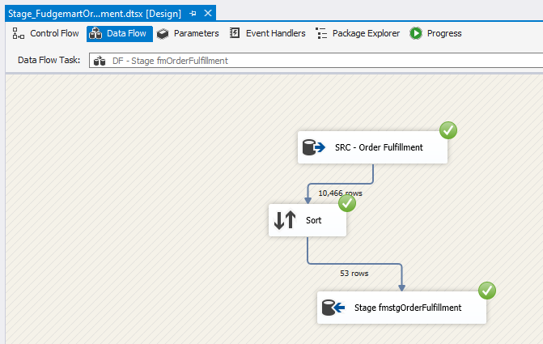

## FudgeFlix Staging:

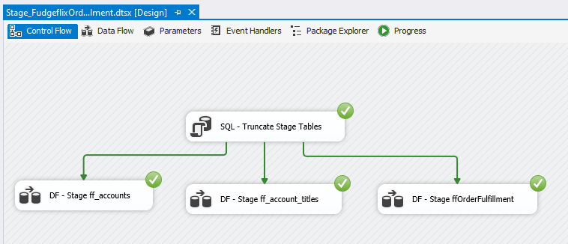

### SRC – FF_Accounts

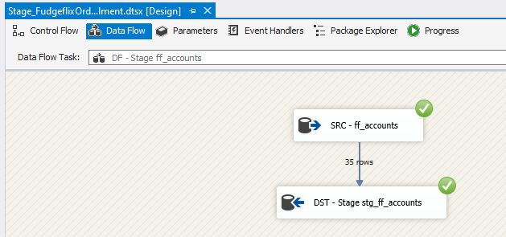

### SRC – FF_accounts_titles

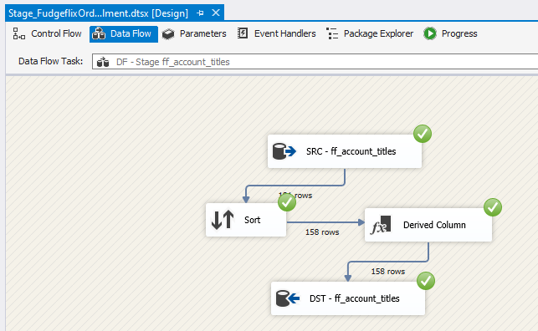

### SRC – FF_Ordefulfillment

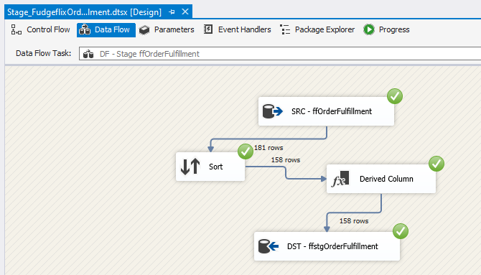

# Loading of Dim Tables and Fact table:

We created a package to complete the ETL from our stage database into our Datawarehouse database. We performed the data transformations required by our target dimensions and fact tables to load the data properly. Also, we used the SCD (Slowly Changing Dimension) pattern to determine whether we need to “pay attention” to the dimension or fact to avoid loading the same data more than once.

1. DW_Customer.dtsx
2. DW_Product.dtsx
3. DW_FactOrderFulfillment.dtsx

## DF – Stage FM and FF to DimCustomer

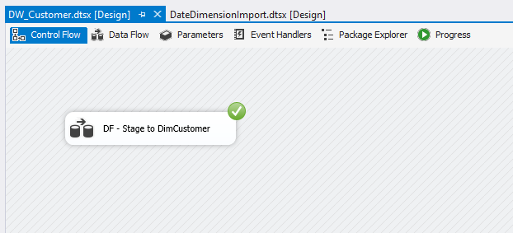

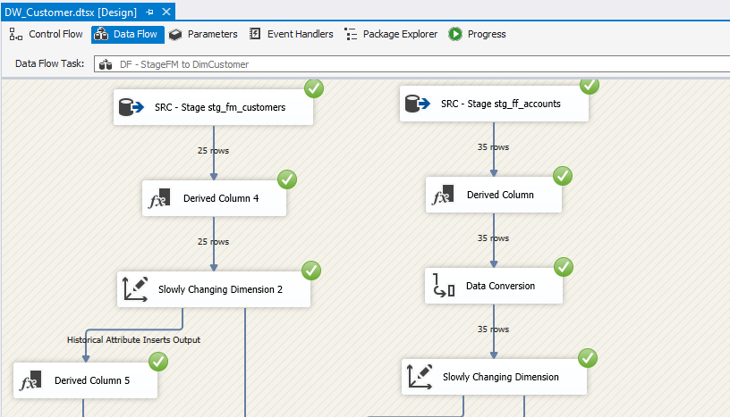

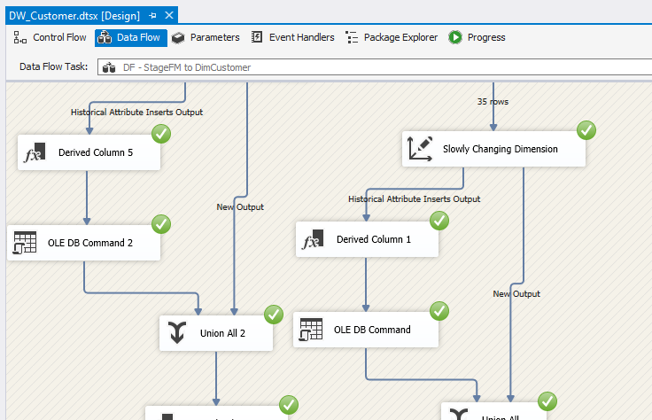

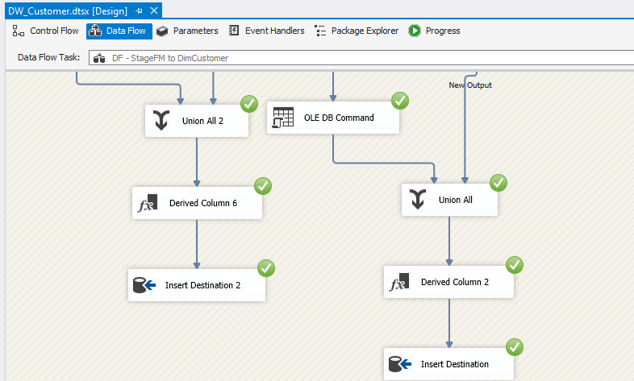

## DF – Stage FM to DimProduct and Stage FF to DimProduct

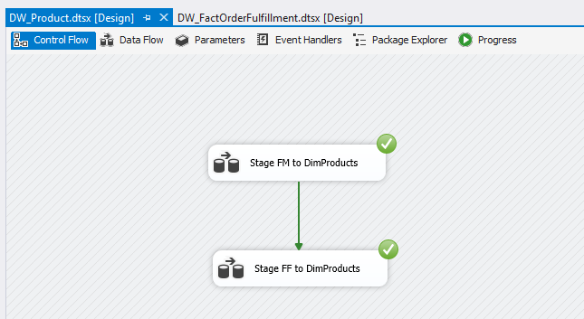

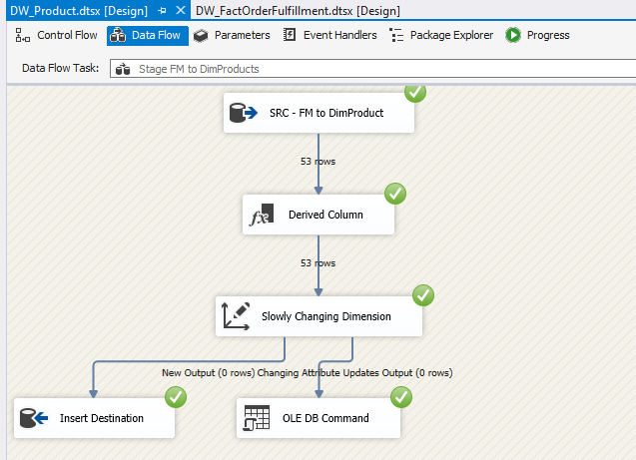

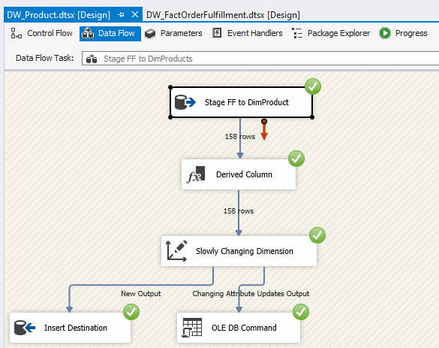

## DF – Stage FM to FactOrderFulfillment and Stage FF to FactOrderFulfillment

